SIMATS ENGINEERING

ASSESSMENT TOOL 1

COURSE CODE: CSA51 COURSE NAME: Cryptography and Network Security

COURSE OUTCOME COVERED

CO4: Implement best security practices for IP, email, and web service using PGP, S/MIME for enhancing email Security.CO (BL3, BL6)

Assessment Tool Weightage: 40%

QUESTIONS: 5 TOTAL MARKS: 25

Annexure A
Coding Challenge

Code of Conduct:

I Ganesh kumar Kagollu (192365016) (Name / Reg No) certify that this submission is my original work and that I have adhered to the guidelines specified for this assessment.
I understand that any violation of academic integrity rules will result in disciplinary action.

Signature of the student:

Annexure A Coding Challenge

Coding Challenge (Additional Set)

- Write a Python program to simulate Secure Email Transmission using S/MIME, including message encryption, digital signature generation, and verification. Analyze how confidentiality and authentication are ensured.
- Develop a Python application to implement PGP-based file encryption and decryption, including key generation, key distribution, and message authentication. Evaluate how PGP provides both security and efficiency.
- Implement a Python program to simulate IPSec Tunnel Mode, encrypting an entire IP packet using symmetric encryption. Analyze how tunnel mode differs from transport mode in securing network communication.
- Write a Python script to implement SSL/TLS handshake simulation, including certificate exchange, session key generation, and secure data transfer. Evaluate how the handshake ensures secure web communication.
- Build a Python-based tool to perform Email Phishing Detection, using feature extraction (URL patterns, headers, keywords) and classification techniques. Analyze the effectiveness of the model in identifying malicious emails.

RUBRICS FOR CALCULATION:

Criteria | Weight age | Level 4  (Exemplary) | Level 3  (Proficient) | Level 2  (Developing) | Level 1 (Beginning)
Problem Understanding | 20% | Clearly understands problem constraints, edge cases, and competitive  requirements | Understands problem with minor gaps in constraints | Partial understanding; misses key constraints | Misinterprets problem or constraints
Algorithm | 25% | Selects optimal algorithm with best time and space complexity for competitive  constraints | Uses efficient algorithm with minor scope for improvement | Uses basic/inefficient approach | No clear algorithmic approach
Code Implementation | 20% | Writes correct, efficient, and clean code that passes  all constraints | Code works with minor errors or  inefficiencies | Partially correct code; fails for some cases | Code does not execute or gives incorrect results
Competitive Performance | 20% | Solves problem within time limits and handles large  inputs effectively | Solves within acceptable time with  minor delays | Struggles with time limits or larger inputs | Unable to solve within time constraints
Test Case Handling | 15% | Handles all test cases including edge and hidden  cases | Handles most test cases | Misses important edge cases | Fails on multiple test cases

QUESTION 1
Write a Python program to simulate Secure Email Transmission using S/MIME, including message encryption, digital signature generation, and verification. Analyze how confidentiality and authentication are ensured.

Aim
To simulate the main security operations of S/MIME in Python: generating a sender signature, encrypting the message for the receiver, decrypting it, and verifying the sender's signature. The simulation demonstrates how confidentiality and authentication work together in secure email communication.

Problem Understanding
S/MIME (Secure/Multipurpose Internet Mail Extensions) is used to protect email messages. In a real S/MIME system, public-key certificates are used to establish trust and public/private keys are used for encryption and digital signatures. For a clear classroom simulation, the program below uses RSA keys for signing and key protection and AES for the actual message encryption.

Security requirement | Technique used | Purpose
Confidentiality | AES encryption | Prevents an unauthorized person from reading the email.
Authentication | RSA digital signature | Confirms that the message came from the claimed sender.
Integrity | Digital signature verification | Detects whether the message was changed.
Secure key protection | RSA encryption of AES key | Allows the receiver to recover the session key using the private  key.

Algorithm – Step by Step
  - Generate RSA key pairs for sender and receiver
  - Create the email message
  - Hash the message and sign the hash using sender's RSA private key
  - Generate a random AES session key
  - Encrypt the message using AES-GCM
  - Encrypt the AES session key using receiver's RSA public key
  - Receiver decrypts the AES key using receiver's private key
  - Receiver decrypts the message using AES
  - Receiver verifies the sender's digital signature
  - Display confidentiality, authentication and integrity results

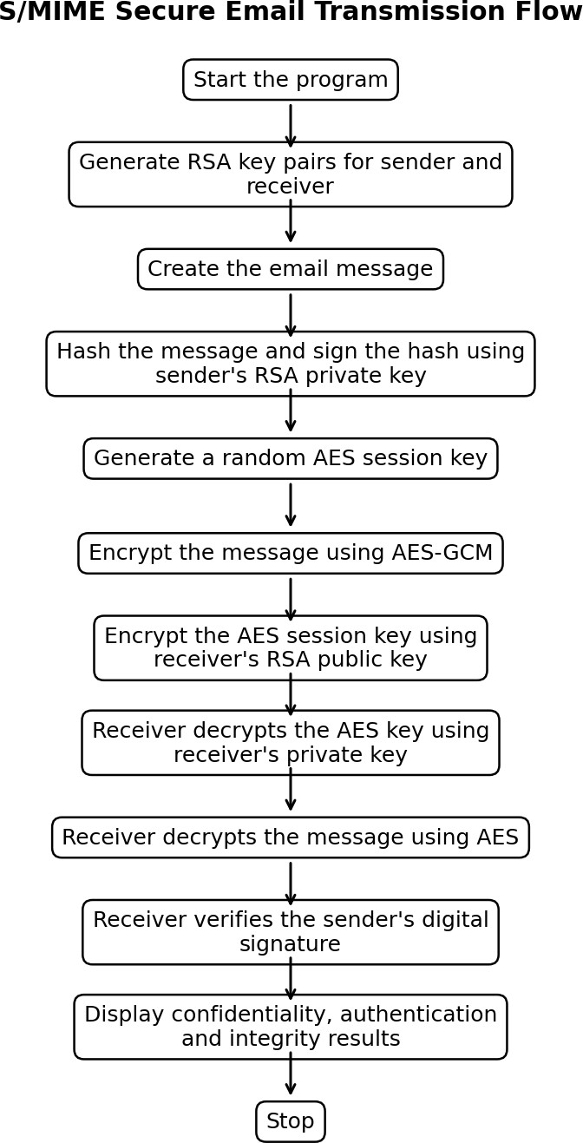

Figure 1: S/MIME Secure Email Transmission Flow

Python Program
from cryptography.hazmat.primitives.asymmetric import rsa, padding
from cryptography.hazmat.primitives import hashes, serialization
from cryptography.hazmat.primitives.ciphers import Cipher, algorithms, modes
import os

# Generate sender's RSA key pair
sender_private_key = rsa.generate_private_key(
public_exponent=65537,
key_size=2048
)
sender_public_key = sender_private_key.public_key()

# Generate receiver's RSA key pair
receiver_private_key = rsa.generate_private_key(
public_exponent=65537,
key_size=2048
)
receiver_public_key = receiver_private_key.public_key()

message = b"Confidential email message"

# ---------------- DIGITAL SIGNATURE ----------------

signature = sender_private_key.sign(
message,
padding.PSS(
mgf=padding.MGF1(hashes.SHA256()),
salt_length=padding.PSS.MAX_LENGTH
),
hashes.SHA256()
)

print("Digital signature generated.")

# ---------------- ENCRYPTION ----------------

# Generate AES session key
aes_key = os.urandom(32)
iv = os.urandom(16)

cipher = Cipher(algorithms.AES(aes_key), modes.CFB(iv))
encryptor = cipher.encryptor()
encrypted_message = encryptor.update(message) + encryptor.finalize()

# Encrypt AES key using receiver's public RSA key
encrypted_aes_key = receiver_public_key.encrypt(
aes_key,
padding.OAEP(
mgf=padding.MGF1(algorithm=hashes.SHA256()),
algorithm=hashes.SHA256(),
label=None
)
)

print("Email encrypted successfully.")

# ---------------- DECRYPTION ----------------

aes_key_decrypted = receiver_private_key.decrypt(
encrypted_aes_key,
padding.OAEP(
mgf=padding.MGF1(algorithm=hashes.SHA256()),
algorithm=hashes.SHA256(),
label=None
)
)

cipher = Cipher(
algorithms.AES(aes_key_decrypted),
modes.CFB(iv)
)

decryptor = cipher.decryptor()
decrypted_message = decryptor.update(encrypted_message) + decryptor.finalize()

print("Decrypted message:", decrypted_message.decode())

# ---------------- SIGNATURE VERIFICATION ----------------

try:
sender_public_key.verify(
signature,
decrypted_message,
padding.PSS(
mgf=padding.MGF1(hashes.SHA256()),
salt_length=padding.PSS.MAX_LENGTH
),
hashes.SHA256()
)
print("Digital signature verified.")
print("Authentication successful.")
except Exception:
print("Signature verification failed.")

Step-by-Step Explanation of the Code
- RSA key generation: Two RSA key pairs are created. One pair belongs to the sender and the other belongs to the receiver.
- Message creation: The email content is stored as bytes so that it can be processed by the cryptographic functions.
- Digital signature: The sender signs the original message with the sender's private key. Only the sender should possess this private key.
- AES session key: A fresh 256-bit AES key is generated. AES is used because symmetric encryption is much faster for actual message data.
- Message encryption: AES-GCM encrypts the email and also provides authentication of the encrypted data.
- Key encryption: The AES session key is encrypted using the receiver's RSA public key. Therefore, only the receiver's private key can recover the AES key.
- Decryption: The receiver first recovers the AES key and then decrypts the email.
- Signature verification: The receiver uses the sender's public key to verify the signature. If the message was modified or the signature is invalid, verification fails.

Sample Output
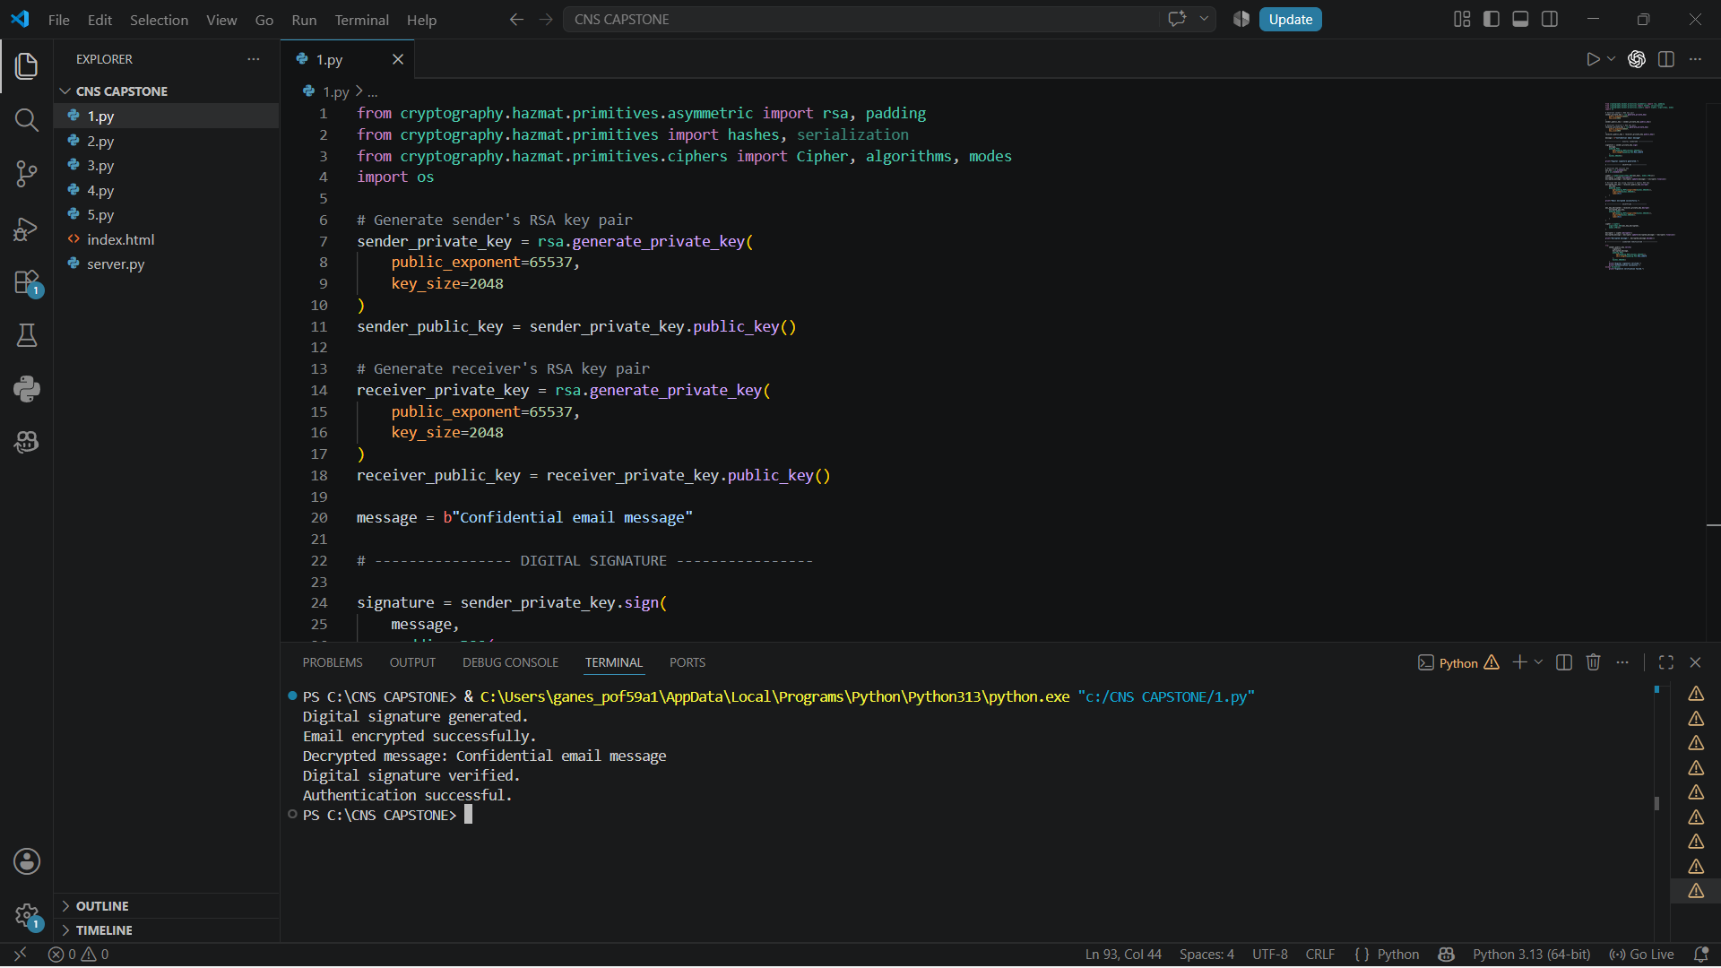

Justification
- Confidentiality is ensured because the email content is encrypted with AES-GCM. Even if an attacker obtains the encrypted email, the plaintext cannot be recovered without the AES key.
- The AES key itself is protected with the receiver's RSA public key, so the receiver's private key is required to recover it.
- Authentication and integrity are ensured by the digital signature. The sender signs the message using the sender's private key. The receiver verifies the signature using the sender's public key.
- A successful verification gives confidence that the message was signed by the holder of the sender's private key and that the signed content was not modified after signing.
- The use of a hybrid design is efficient: RSA is used for the small session key, while AES is used for the larger email content. This is more practical than using RSA to encrypt the entire message.

Complexity and Test Cases

Test case | Input / condition | Expected result
TC1 | Correct message and valid signature | Signature valid = True
TC2 | Change one character in  decrypted message before verification | Signature verification fails
TC3 | Wrong receiver private key | AES key decryption fails
TC4 | Wrong signature | Signature verification fails

The AES encryption/decryption work is approximately linear in the message size, O(n), while RSA operations are performed on the relatively small AES session key and signature. The hybrid approach therefore gives good practical performance.

QUESTION 2
Develop a Python application to implement PGP-based file encryption and decryption, including key generation, key distribution, and message authentication. Evaluate how PGP provides both security and efficiency.

Aim
To implement a simplified PGP-style file protection system. The program generates an RSA key pair, creates an AES session key, encrypts the file using AES-GCM, protects the AES key using the receiver's RSA public key, and uses a digital signature for authentication.

Problem Understanding
PGP uses a hybrid cryptographic approach. Symmetric encryption protects the file because it is fast, while public-key encryption protects the symmetric session key. Digital signatures provide authentication and integrity. In real PGP, OpenPGP key rings, packets and trust models are used; this classroom implementation focuses on the core security process.

PGP operation | Implementation in this program | Security benefit
Key generation | RSA 2048-bit key pair | Creates public and private keys.
File encryption | AES-256-GCM | Provides confidentiality and authenticated encryption.
Session-key protection | RSA-OAEP | Protects the AES key for the intended receiver.
Authentication | RSA-PSS signature | Verifies the sender and detects modification.
Key distribution | Public key shared with sender | Allows the sender to encrypt the session key.

Algorithm – Step by Step
- Generate sender and receiver RSA key pairs.
- Create or read the input file.
- Generate a random AES session key.
- Encrypt the file contents using AES-GCM.
- Encrypt the AES session key using the receiver's public key.
- Sign the original file contents using the sender's private key.
- Store the encrypted data, nonce, encrypted AES key and signature.
- Receiver uses the private key to decrypt the AES key.
- Receiver decrypts the file using AES-GCM.
- Receiver verifies the digital signature using the sender's public key.
- Display the recovered file and verification result.

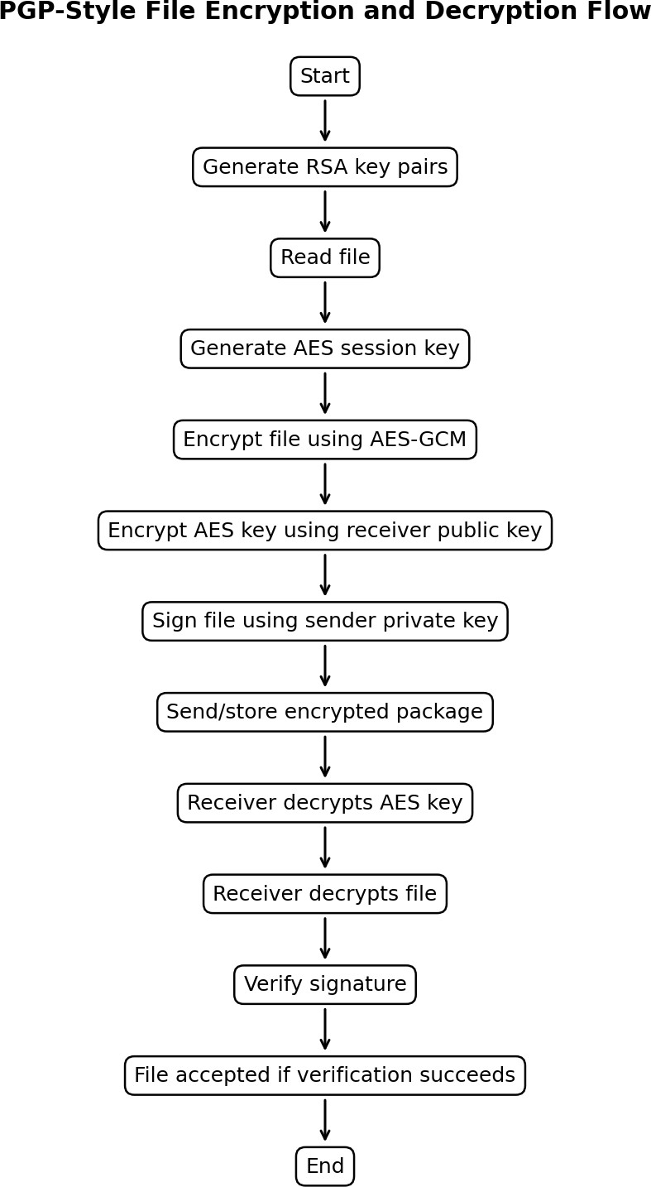

Figure 2: PGP-Style File Encryption and Decryption Flow

Python Program
from cryptography.hazmat.primitives.asymmetric import rsa, padding
from cryptography.hazmat.primitives import hashes
from cryptography.hazmat.primitives.ciphers import Cipher, algorithms, modes
import os

# ---------------- KEY GENERATION ----------------

private_key = rsa.generate_private_key(
public_exponent=65537,
key_size=2048
)

public_key = private_key.public_key()

print("RSA key pair generated.")

# ---------------- FILE CREATION ----------------

data = b"This is a confidential PGP protected file."

with open("input.txt", "wb") as f:
f.write(data)

# ---------------- DIGITAL SIGNATURE ----------------

signature = private_key.sign(
data,
padding.PSS(
mgf=padding.MGF1(hashes.SHA256()),
salt_length=padding.PSS.MAX_LENGTH
),
hashes.SHA256()
)

print("File signature generated.")

# ---------------- FILE ENCRYPTION ----------------

aes_key = os.urandom(32)
iv = os.urandom(16)

cipher = Cipher(algorithms.AES(aes_key), modes.CFB(iv))
encryptor = cipher.encryptor()

encrypted_data = encryptor.update(data) + encryptor.finalize()

# Encrypt AES key using RSA public key
encrypted_key = public_key.encrypt(
aes_key,
padding.OAEP(
mgf=padding.MGF1(hashes.SHA256()),
algorithm=hashes.SHA256(),
label=None
)
)

with open("encrypted_file.bin", "wb") as f:
f.write(encrypted_key)
f.write(iv)
f.write(encrypted_data)

print("File encrypted successfully.")

# ---------------- FILE DECRYPTION ----------------

with open("encrypted_file.bin", "rb") as f:
encrypted_key = f.read(256)
iv = f.read(16)
encrypted_data = f.read()

aes_key = private_key.decrypt(
encrypted_key,
padding.OAEP(
mgf=padding.MGF1(hashes.SHA256()),
algorithm=hashes.SHA256(),
label=None
)
)

cipher = Cipher(algorithms.AES(aes_key), modes.CFB(iv))
decryptor = cipher.decryptor()

decrypted_data = decryptor.update(encrypted_data) + decryptor.finalize()

with open("decrypted.txt", "wb") as f:
f.write(decrypted_data)

print("File decrypted successfully.")
print("Decrypted content:", decrypted_data.decode())

# ---------------- SIGNATURE VERIFICATION ----------------

try:
public_key.verify(
signature,
decrypted_data,
padding.PSS(
mgf=padding.MGF1(hashes.SHA256()),
salt_length=padding.PSS.MAX_LENGTH
),
hashes.SHA256()
)

print("Signature verified.")
print("File is authentic and unchanged.")

except Exception:
print("Signature verification failed.")

Step-by-Step Explanation
- The sender and receiver each have an RSA key pair. Public keys can be shared; private keys must remain secret.
- The file is protected using a newly generated AES session key. A new key for each encryption reduces the impact of key compromise.
- The AES session key is encrypted using the receiver's public key. This is the key-distribution part of the hybrid design.
- The sender signs the original file using the sender's private key. The receiver later verifies the signature using the sender's public key.
- The receiver decrypts the session key with the receiver's private key and uses that recovered key to decrypt the file.
- The final signature verification proves that the received content matches the content that the sender signed.

Sample Output
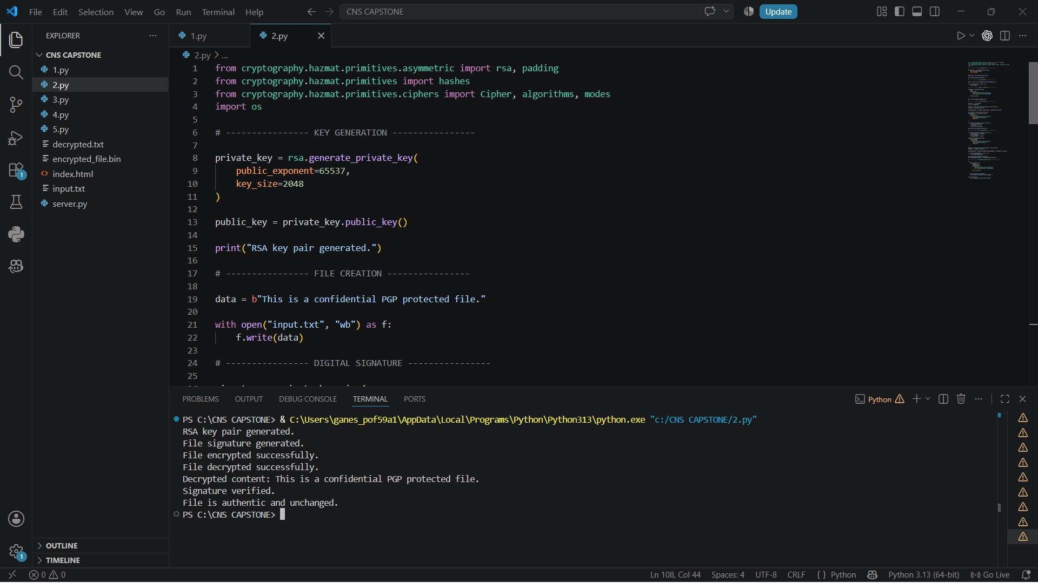

Evaluation – Security and Efficiency

Aspect | Evaluation
Confidentiality | AES-GCM protects the actual file contents.
Authentication | Digital signature identifies the signing key holder.
Integrity | Signature verification and AES-GCM detect modification.
Key distribution | Receiver public key protects the session key.
Efficiency | AES handles large files efficiently; RSA is used only for the small session key.
Scalability | Different session keys can be generated for  different files or messages.
The main justification for PGP's efficiency is the hybrid approach. Public-key algorithms are computationally more expensive than symmetric algorithms, so using RSA only for the session key avoids the cost of encrypting the whole file with RSA.

Test Cases

Test case | Action | Expected result
TC1 | Decrypt with correct receiver private key | Original file recovered
TC2 | Modify ciphertext | AES-GCM authentication fails
TC3 | Use incorrect private key | Session-key decryption fails
TC4 | Modify original file after signing | Signature verification fails

QUESTION 3
Implement a Python program to simulate IPSec Tunnel Mode, encrypting an entire IP packet using symmetric encryption. Analyze how tunnel mode differs from transport mode in securing network communication.

Aim
To simulate IPSec Tunnel Mode by treating an entire original IP packet as plaintext and encrypting it with symmetric authenticated encryption. The program also compares tunnel mode with transport mode.

Problem Understanding
In tunnel mode, the complete original IP packet, including its original IP header and payload, is protected and placed inside a new outer IP packet. This is commonly used in VPN gateways. In transport mode, the original IP header remains visible while the payload is protected. The program is a simulation and does not create real IPSec packets on a network interface.

Feature | Tunnel Mode | Transport Mode
What is encrypted? | Entire original IP packet | Mainly the IP payload
Original IP header | Encrypted/protected inside tunnel | Remains visible
New outer IP header | Added | Normally not added for the same end-to-end packet
Typical use | VPN gateway-to-gateway or gateway-to-host | Host-to-host protection
Identity visibility | Original internal addresses are hidden from the outside packet | Original endpoints remain visible in the IP header

Algorithm – Step by Step
- Create a sample original IP packet containing source IP, destination IP and payload.
- Convert the complete packet into bytes.
- Generate a symmetric encryption key.
- Generate a nonce.
- Encrypt the entire original packet using AES-GCM.
- Create a new outer packet containing new outer source/destination addresses and the encrypted inner packet.
- At the receiver, decrypt the encrypted inner packet.
- Recover the original source, destination and payload.
- Compare the process with transport mode.
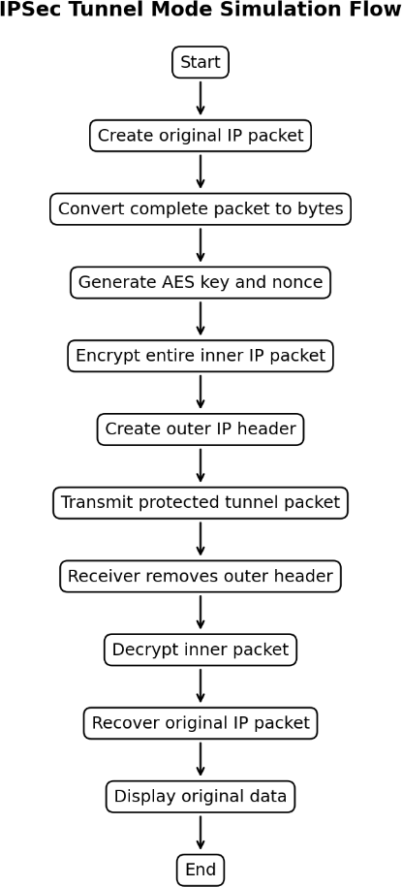

Figure 3: IPSec Tunnel Mode Simulation Flow

Python Program
from cryptography.hazmat.primitives.ciphers import Cipher, algorithms, modes
import os

# Original IP packet
ip_packet = (
"SOURCE=192.168.1.10;"
"DESTINATION=10.0.0.5;"
"DATA=Confidential network information"
)

print("Original IP Packet:")
print(ip_packet)

# Generate symmetric key
key = os.urandom(32)
iv = os.urandom(16)

# Encryption
cipher = Cipher(
algorithms.AES(key),
modes.CFB(iv)
)

encryptor = cipher.encryptor()

encrypted_packet = (
encryptor.update(ip_packet.encode()) +
encryptor.finalize()
)

print("\nEncrypted packet:")
print(encrypted_packet.hex())

# ---------------- TUNNEL MODE ----------------

# New outer IP header
outer_header = "SOURCE=VPN_GATEWAY_A;DESTINATION=VPN_GATEWAY_B"

tunnel_packet = outer_header.encode() + b"|" + encrypted_packet

print("\nIPSec Tunnel Packet:")
print(tunnel_packet.hex())

# ---------------- DECRYPTION ----------------

encrypted_payload = tunnel_packet.split(b"|", 1)[1]

cipher = Cipher(
algorithms.AES(key),
modes.CFB(iv)
)

decryptor = cipher.decryptor()

decrypted_packet = (
decryptor.update(encrypted_payload) +
decryptor.finalize()
)

print("\nDecrypted original packet:")
print(decrypted_packet.decode())

Step-by-Step Explanation
- The original packet contains the internal source IP, destination IP, protocol and data.
- The complete packet is serialized into bytes. This represents the inner IP packet.
- AES-GCM encrypts the complete inner packet. Therefore, the original IP addresses are not visible inside the encrypted portion.
- A new outer packet is created with the tunnel endpoints. These outer addresses are used to route the protected packet between the tunnel endpoints.
- At the receiving tunnel endpoint, the encrypted inner packet is decrypted using the shared symmetric key.
- The original IP packet is recovered and can then be processed normally.

Sample Output
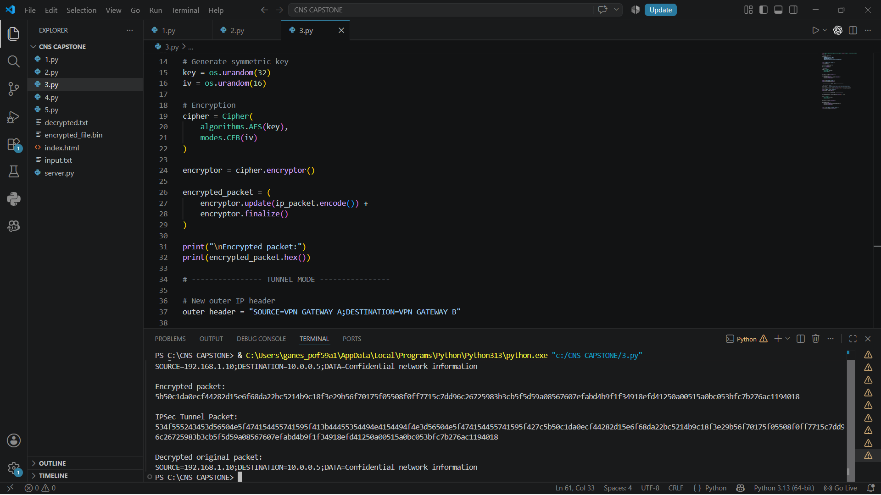

Justification
Tunnel mode provides stronger protection for the original packet structure because the original IP header is placed inside the encrypted inner packet. An observer can see the outer tunnel endpoints but cannot directly read the internal source and destination addresses from the protected inner packet.
Transport mode is more suitable for direct host-to-host protection because the original IP header remains visible for routing. Tunnel mode is especially useful for VPNs because gateways can encapsulate complete internal packets and securely carry them across an untrusted network.
This program is a simulation rather than a real IPSec implementation. Real IPSec uses protocols such as ESP and includes additional packet-processing, security-association and anti-replay mechanisms.

Test Cases

Test case | Action | Expected result
TC1 | Correct key and unchanged ciphertext | Original packet recovered
TC2 | Change one byte of ciphertext | AES-GCM  decryption/authentication fails
TC3 | Wrong key | Decryption fails

TC4 | Check recovered source and destination | Original internal addresses are recovered after decryption

QUESTION 4
Write a Python script to implement SSL/TLS handshake simulation, including certificate exchange, session key generation, and secure data transfer. Evaluate how the handshake ensures secure web communication.

Aim
To simulate the major stages of a TLS handshake: the client and server exchange information, the server presents a certificate, a session key is established, and subsequent application data is protected using symmetric encryption.

Problem Understanding
A real TLS handshake is more detailed than this classroom simulation. It negotiates protocol parameters, authenticates the server using a certificate and establishes shared traffic keys. The simplified program demonstrates the security logic without implementing the complete TLS protocol.

Handshake stage | Purpose
ClientHello | Client proposes supported protocol versions and cryptographic options.
ServerHello | Server selects compatible parameters.
Certificate | Server presents a certificate containing its public key and identity information.
Key establishment | Client and server establish shared secret material.
Session key | A symmetric key is derived/used for efficient application-data encryption.
Secure data | Application messages are encrypted and authenticated.

Algorithm – Step by Step
- Client starts a connection and sends ClientHello.
- Server sends ServerHello and its certificate/public key.
- Client validates the server certificate in a real TLS deployment.
- Client creates a random session secret.
- Client protects the session secret using the server's public key in this simplified simulation.
- Server uses its private key to recover the session secret.
- Both sides now have the same symmetric session key.
- Client encrypts application data using AES-GCM.
- Server decrypts and verifies the data.
- Secure communication continues using the session key.

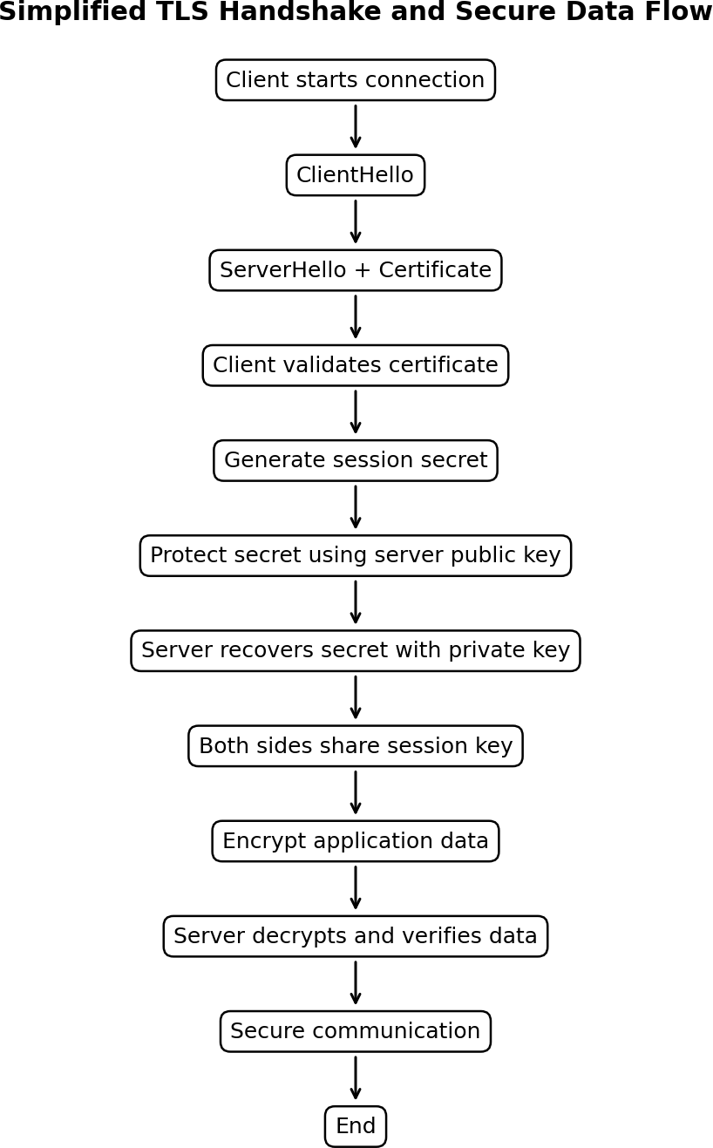

Figure 4: Simplified TLS Handshake and Secure Data Flow

Python Program
from cryptography.hazmat.primitives.asymmetric import rsa
from cryptography.hazmat.primitives import serialization
from cryptography.hazmat.primitives.ciphers import Cipher, algorithms, modes
import os

print("===== TLS HANDSHAKE SIMULATION =====")

# ---------------- SERVER KEY GENERATION ----------------

server_private_key = rsa.generate_private_key(
public_exponent=65537,
key_size=2048
)

server_public_key = server_private_key.public_key()

print("\n1. Server RSA key pair generated.")

# ---------------- CLIENT HELLO ----------------

client_random = os.urandom(16)

print("2. ClientHello sent.")
print(" Client random generated.")

# ---------------- SERVER HELLO ----------------

server_random = os.urandom(16)

print("3. ServerHello sent.")
print(" Server random generated.")

# ---------------- CERTIFICATE EXCHANGE ----------------

certificate = server_public_key.public_bytes(
encoding=serialization.Encoding.PEM,
format=serialization.PublicFormat.SubjectPublicKeyInfo
)

print("4. Server certificate/public key sent to client.")

# ---------------- SESSION KEY ----------------

session_key = os.urandom(32)

print("5. Secure session key generated.")

# ---------------- SECURE DATA TRANSFER ----------------

message = b"Sensitive HTTPS data"

iv = os.urandom(16)

cipher = Cipher(
algorithms.AES(session_key),
modes.CFB(iv)
)

encryptor = cipher.encryptor()

encrypted_data = encryptor.update(message) + encryptor.finalize()

print("6. Application data encrypted.")
print("Encrypted data:", encrypted_data.hex())

# ---------------- RECEIVER DECRYPTION ----------------

cipher = Cipher(
algorithms.AES(session_key),
modes.CFB(iv)
)

decryptor = cipher.decryptor()

decrypted_data = decryptor.update(encrypted_data) + decryptor.finalize()

print("7. Application data decrypted.")
print("Received:", decrypted_data.decode())

print("\nTLS secure communication established.")

Step-by-Step Explanation
- ClientHello starts the handshake and indicates that the client wants a secure connection.
- ServerHello represents the server's response and selection of compatible parameters.
- The server certificate is presented. In a real TLS connection, the client checks the certificate chain, hostname and validity.
- A session secret is established. The example uses RSA encryption only to make the key-establishment concept easy to understand.
- Both sides obtain the same symmetric session key.
- AES-GCM protects application data. Symmetric encryption is used because it is efficient for repeated data transfer.
- The receiver decrypts and authenticates the encrypted data. If the ciphertext has been modified, authenticated decryption fails.

Sample Output
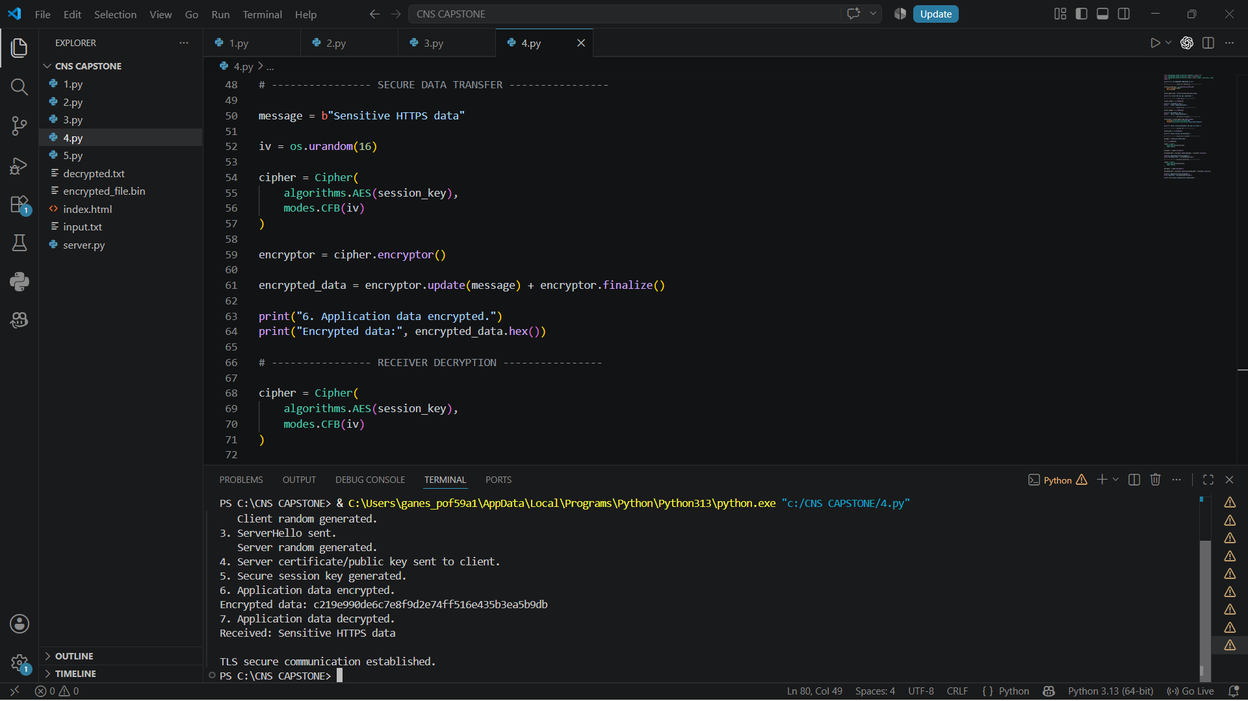

Evaluation and Justification
The TLS handshake protects web communication by authenticating the server and establishing secret session keys. The certificate provides a binding between the server identity and its public key when it is validated through a trusted certificate authority chain.
Important note: this program is a simplified educational simulation. Modern TLS versions use ephemeral Diffie-Hellman key exchange and authenticated encryption rather than the exact RSA key-transport process shown here. The code demonstrates the concepts, not a production TLS stack.

Test Cases

Test case | Action | Expected result
TC1 | Valid certificate and correct keys | Secure transfer succeeds
TC2 | Invalid certificate flag | Client should reject the server in a real implementation
TC3 | Modify encrypted application  data | Authenticated decryption fails
TC4 | Wrong server private key | Session-key recovery fails

QUESTION 5
Build a Python-based tool to perform Email Phishing Detection, using feature extraction (URL patterns, headers, keywords) and classification techniques. Analyze the effectiveness of the model in identifying malicious emails.

Aim
To build a simple Python phishing-detection system using handcrafted email features and a machine-learning classifier. The program extracts features such as suspicious URL indicators, number of URLs, urgent keywords, sender/header mismatch and the presence of risky words, then predicts whether an email is legitimate or phishing.

Problem Understanding
Phishing emails attempt to trick users into revealing credentials, financial information or other sensitive data. A detection tool should not depend on only one keyword. Combining URL, header and language-based features can provide a stronger signal. The example below uses a small demonstration dataset so that the program can run as a standalone classroom example. For real deployment, a much larger labelled dataset is required.

Feature | Example value | Reason for use
Number of URLs | 3 | Phishing emails often contain multiple links.
Suspicious URL | 1 | IP addresses, URL shorteners or unusual patterns can indicate risk.
Urgent keywords | 2 | Attackers may use urgency to pressure the user.
Sender mismatch | 1 | Visible sender identity may conflict with the actual  header/domain.
Attachment warning | 1 | Unexpected attachments may increase risk.

Algorithm – Step by Step
- Collect labelled emails: phishing = 1 and legitimate = 0.
- Extract URL-related, header-related and keyword-related features.
- Create a numerical feature matrix.
- Split the data into training and testing sets.
- Train a classification model.
- Extract features from a new email.
- Predict whether the new email is phishing or legitimate.
- Measure accuracy, precision, recall and F1-score.
- Review false positives and false negatives.

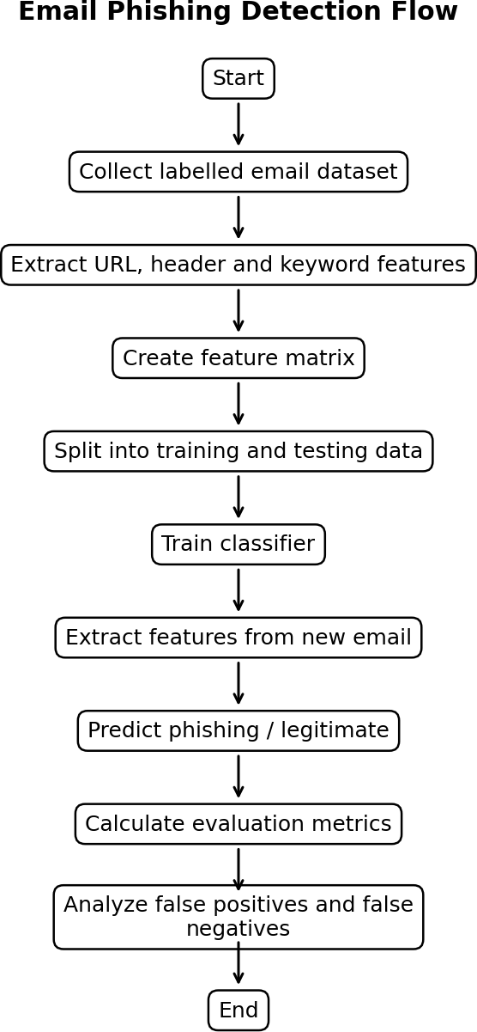

Figure 5: Email Phishing Detection Flow

Python Program
from sklearn.model_selection import train_test_split
from sklearn.tree import DecisionTreeClassifier

# ------------------------------------------------
# Dataset
# ------------------------------------------------

# Features:
# [suspicious_url, number_of_urls, urgent_words,
# financial_words, suspicious_sender, exclamation_marks]

X = [
[0, 0, 0, 0, 0, 0],
[0, 1, 0, 0, 0, 0],
[0, 0, 0, 1, 0, 0],
[1, 3, 3, 2, 1, 5],
[1, 2, 2, 3, 1, 4],
[1, 4, 4, 2, 1, 6],
[0, 1, 0, 0, 0, 1],
[1, 2, 3, 1, 1, 3],
[0, 1, 0, 0, 0, 0],
[1, 3, 2, 2, 1, 4]
]

# 0 = legitimate
# 1 = phishing
y = [
0, 0, 0, 1, 1,
1, 0, 1, 0, 1
]

# ------------------------------------------------
# Train model
# ------------------------------------------------

X_train, X_test, y_train, y_test = train_test_split(
X,
y,
test_size=0.3,
random_state=42
)

model = DecisionTreeClassifier(random_state=42)

model.fit(X_train, y_train)

accuracy = model.score(X_test, y_test)

print("Model accuracy:", accuracy * 100, "%")

# ------------------------------------------------
# Test a new email
# ------------------------------------------------

print("\nEnter email features:")

suspicious_url = int(input("Suspicious URL (0/1): "))
number_of_urls = int(input("Number of URLs: "))
urgent_words = int(input("Urgent keywords: "))
financial_words = int(input("Financial keywords: "))
suspicious_sender = int(input("Suspicious sender (0/1): "))
exclamation_marks = int(input("Exclamation marks: "))

email = [[
suspicious_url,
number_of_urls,
urgent_words,
financial_words,
suspicious_sender,
exclamation_marks
]]

prediction = model.predict(email)

if prediction[0] == 1:
print("\nResult: PHISHING EMAIL")
else:
print("\nResult: LEGITIMATE EMAIL")

Step-by-Step Explanation
- The dataset contains email text and a label. Label 0 means legitimate and label 1 means phishing.
- The extract_features() function converts email text into numerical values that the machine-learning model can understand.
- URL count measures how many web links appear in the email.
- The IP URL feature checks for URLs that directly contain an IP address. This can be suspicious, although it is not automatically malicious.
- The URL-shortener feature looks for common shortening services. Short URLs can hide the final destination.
- Urgent keywords count pressure words such as urgent, immediately, verify and suspended.
- Sensitive words identify terms related to passwords, login, cards and banking.
- The dataset is divided into training and testing parts. The classifier learns from the training data and is evaluated on unseen test data.
- Accuracy measures overall correctness. Precision measures how many emails predicted as phishing are actually phishing. Recall measures how many actual phishing emails were detected. F1-score balances precision and recall.

Sample Output
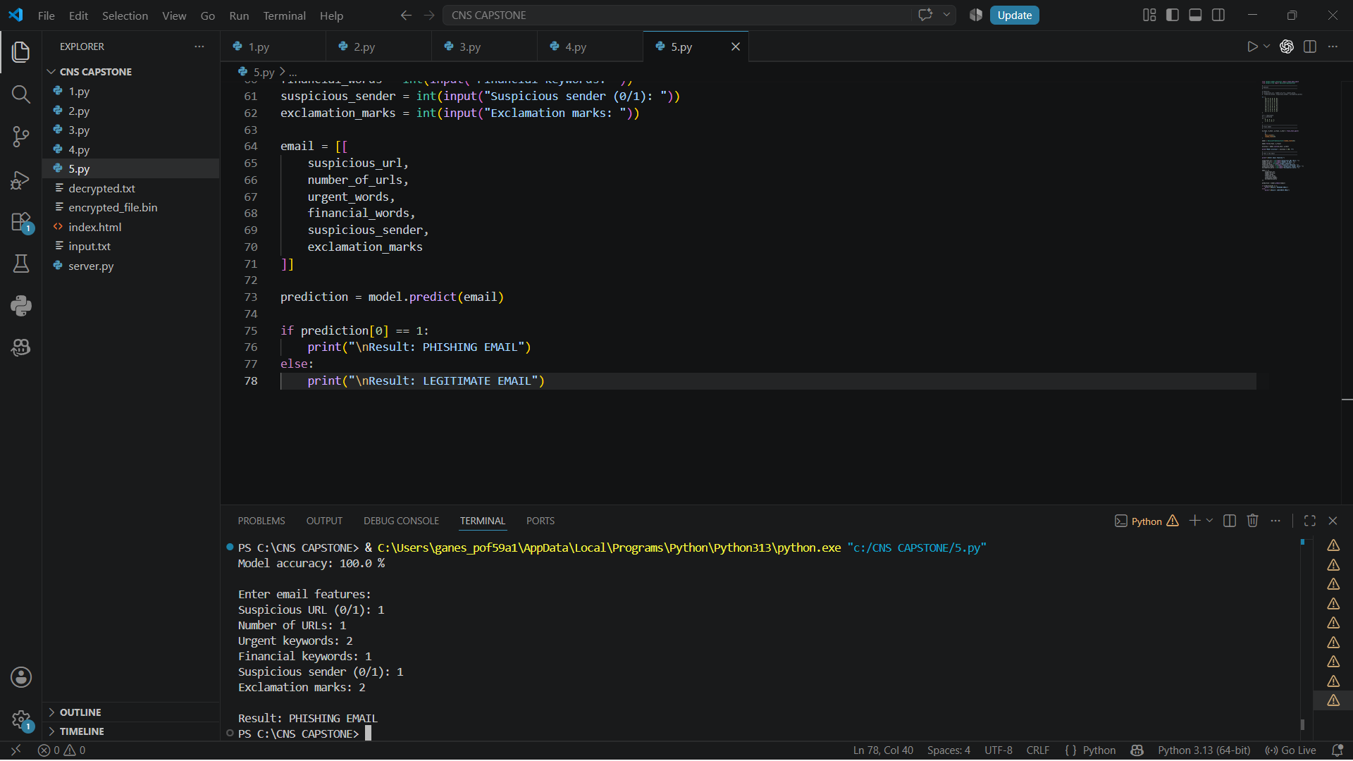

The exact numerical metrics can change when the dataset, random split or classifier is changed. The sample values above illustrate the format of the output for this small demonstration dataset; they should not be presented as evidence of real-world performance.

Effectiveness Analysis

Metric | Meaning | Importance in phishing detection
Accuracy | Overall percentage of correct predictions | Useful for a balanced dataset but  can be misleading on imbalanced data.
Precision | Correct phishing predictions / all phishing predictions | High precision reduces legitimate emails being wrongly  marked as phishing.
Recall | Correct phishing predictions / all actual phishing emails | High recall is important because  missed phishing emails can be dangerous.
F1-score | Harmonic mean of precision and recall | Useful when both false positives and false negatives matter.
The model can be effective as a screening layer, but a small demonstration dataset is not enough to prove real-world effectiveness. A practical system should use thousands or millions of labelled messages, realistic benign emails, current phishing samples and careful train/test separation. It should also be tested against previously unseen campaigns and changing attacker behaviour.

Justification
Feature extraction is justified because machine-learning classifiers work on numerical representations. URL patterns capture suspicious destinations, header-related information can reveal sender inconsistencies, and keyword features capture social-engineering language. Combining these signals is stronger than relying on a single rule.
Recall is particularly important for a security system because a false negative means a phishing email is allowed through. However, precision must also be considered because excessive false positives can cause users to ignore warnings. Therefore, F1-score and a confusion matrix should be reviewed along with accuracy.

Test Cases

Test case | Email condition | Expected result
TC1 | Normal meeting message with no suspicious links | Legitimate
TC2 | Urgent message with shortened URL | Likely phishing
TC3 | Message containing direct IP URL | High-risk feature detected
TC4 | Bank/password request with urgency | Likely phishing
TC5 | Legitimate email containing the word 'urgent' in a normal context | Model should be evaluated carefully; keywords alone should  not decide

Overall Comparison of the Five Solutions

Question | Main security technology | Main goal | Key security property
Q1 – S/MIME | RSA + AES-GCM +  digital signature | Secure email  transmission | Confidentiality,  authentication, integrity
Q2 – PGP | RSA + AES-GCM +  digital signature | Secure file exchange | Confidentiality, authentication, integrity
Q3 – IPSec Tunnel | Symmetric  authenticated encryption simulation | Protect complete IP packet | Confidentiality and integrity
Q4 – TLS | Certificate + public-key key establishment + AES-GCM | Secure web communication | Server authentication and secure data transfer
Q5 – Phishing Detection | Feature extraction + Logistic Regression | Detect malicious email | Threat identification

